Assignment -2
- To capture and analyze ICMP packets (Ping request and reply)
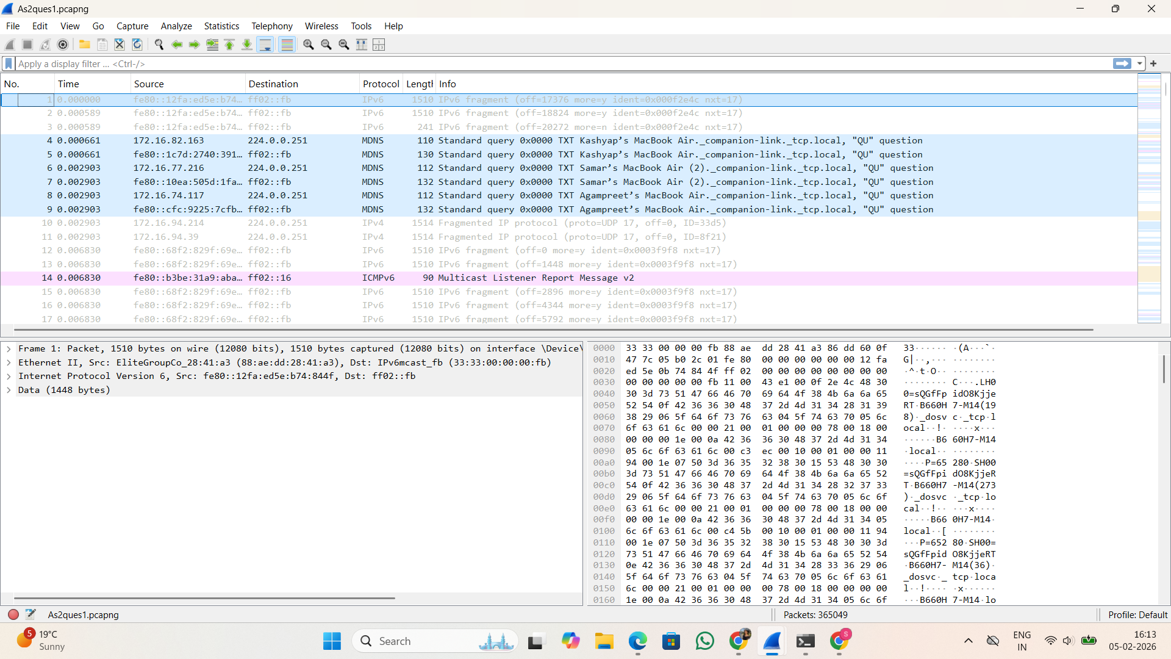

- To analyze TCP packets and observe the TCP three-way handshake
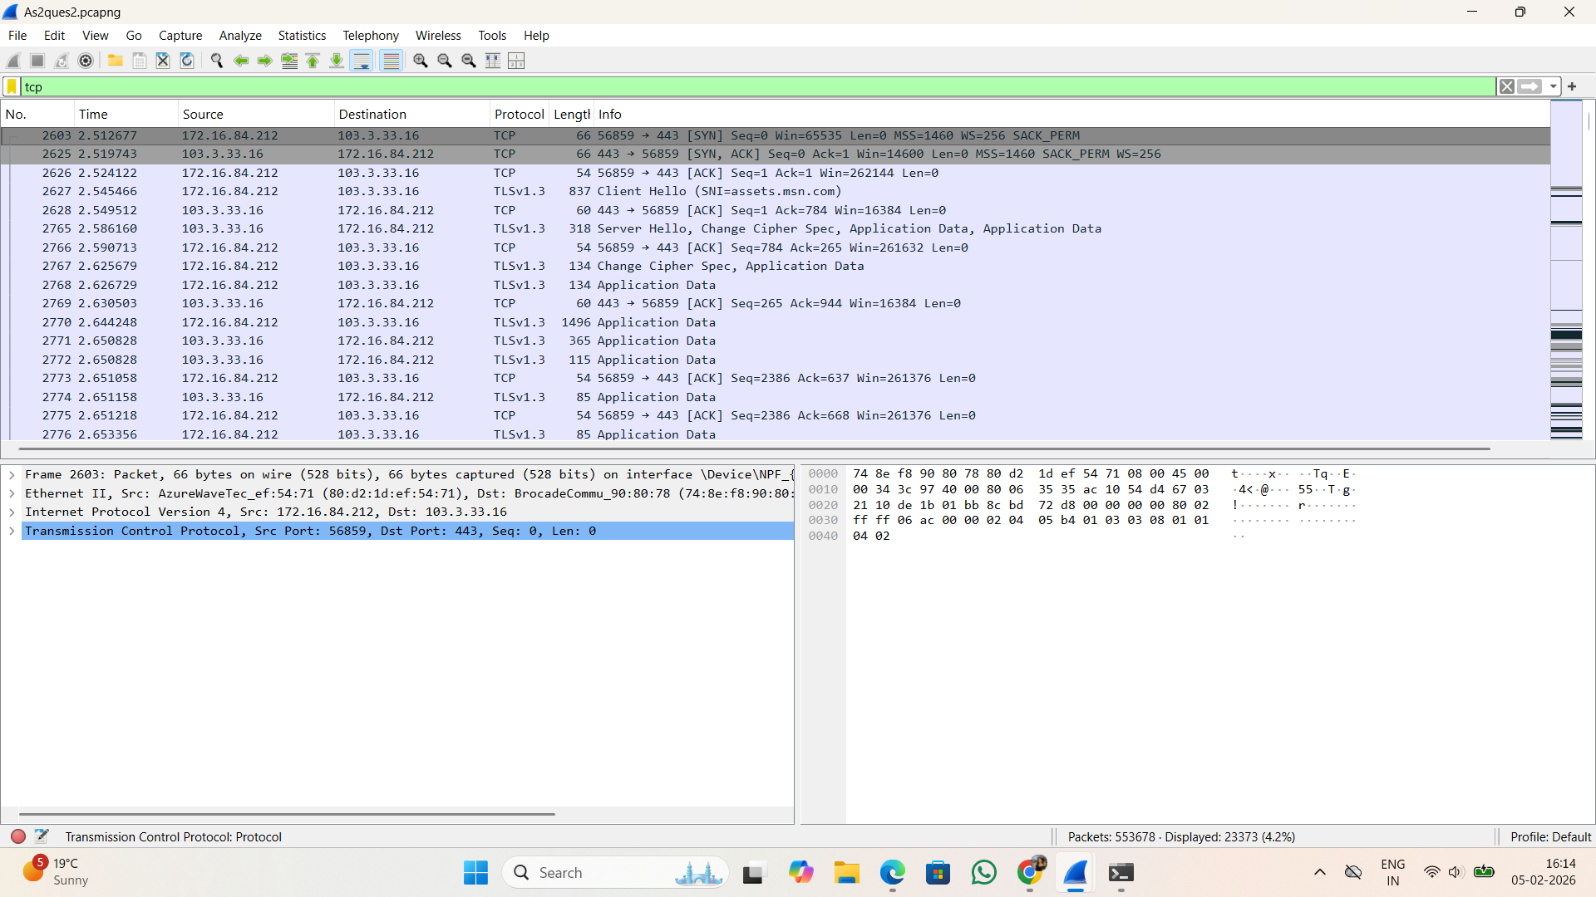

- To capture and analyze UDP packets
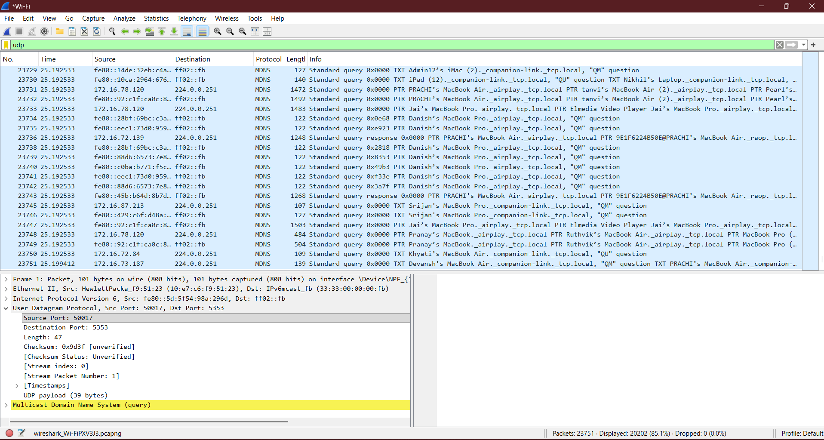

- To capture and analyze DNS query and response packets
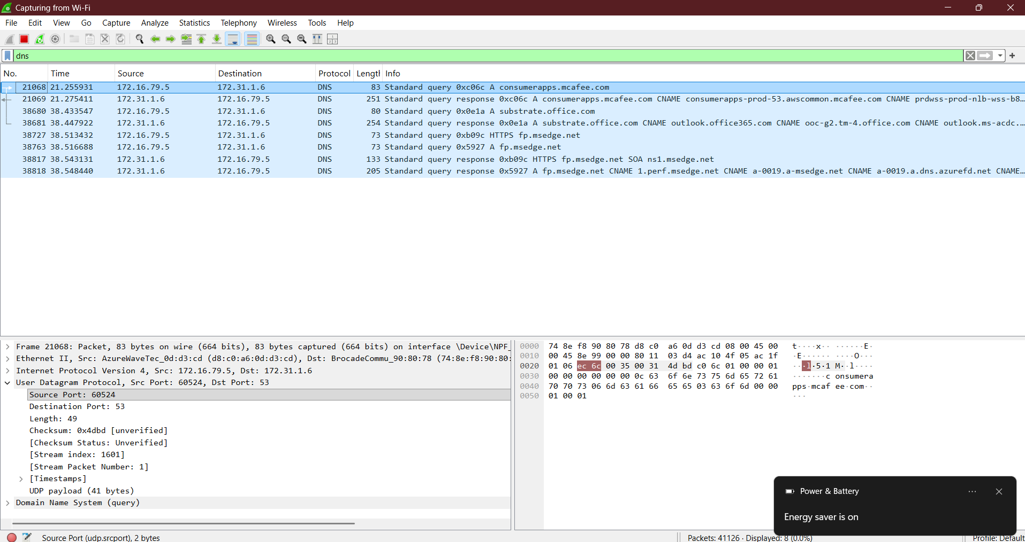

- To capture and analyze HTTP packets
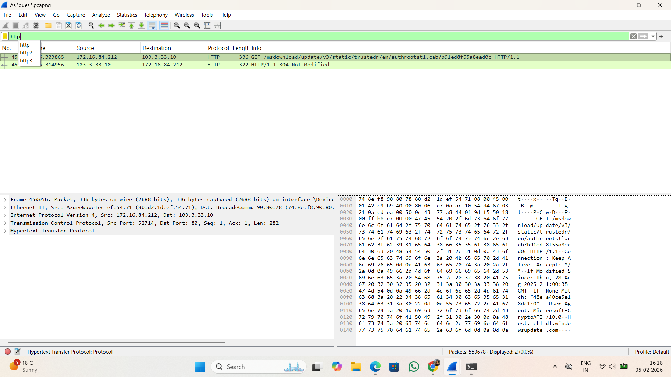

- To analyze ARP request and reply packets
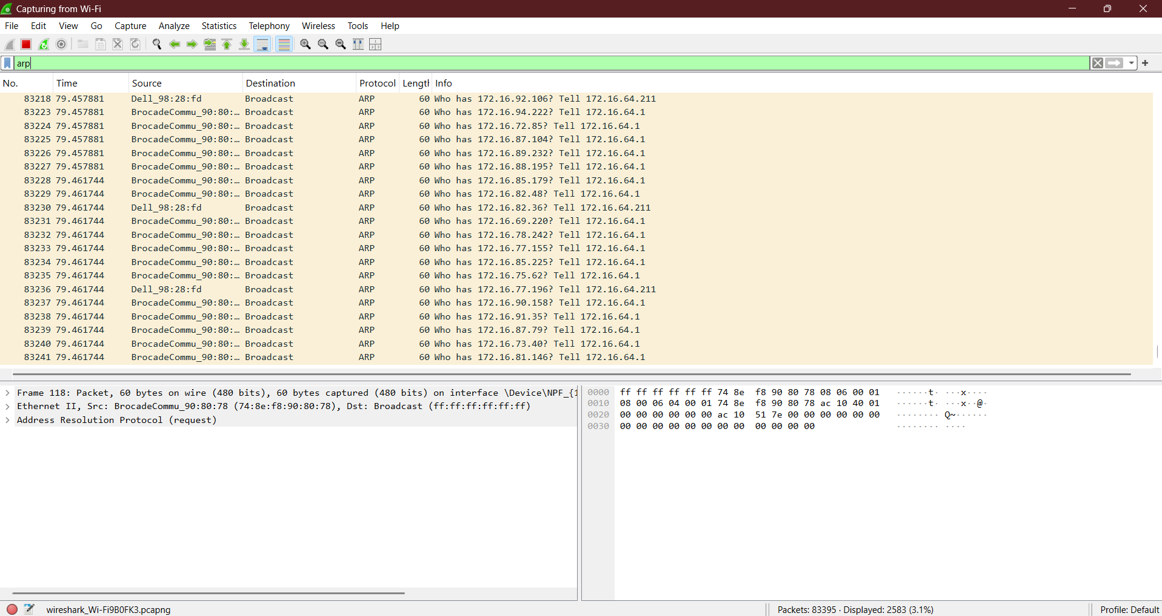

- To identify source and destination MAC and IP addresses in captured packets
